**Function Point Metrics**

**Made by-**

**Anjali Srivastava 21/5023**

**Prachiti Gupta 21/5031**

**Sania Sachdev 21/5034**



Number of External Inputs:0

Number of External Outputs:0

Number of External Inquiries:0

Number of External Interfaces:0

Number of Internal Logical Files:0



Number of External Inputs:5

Number of External Outputs:1

Number of External Inquiries:0

Number of External Interfaces:0

Number of Internal Logical Files:1

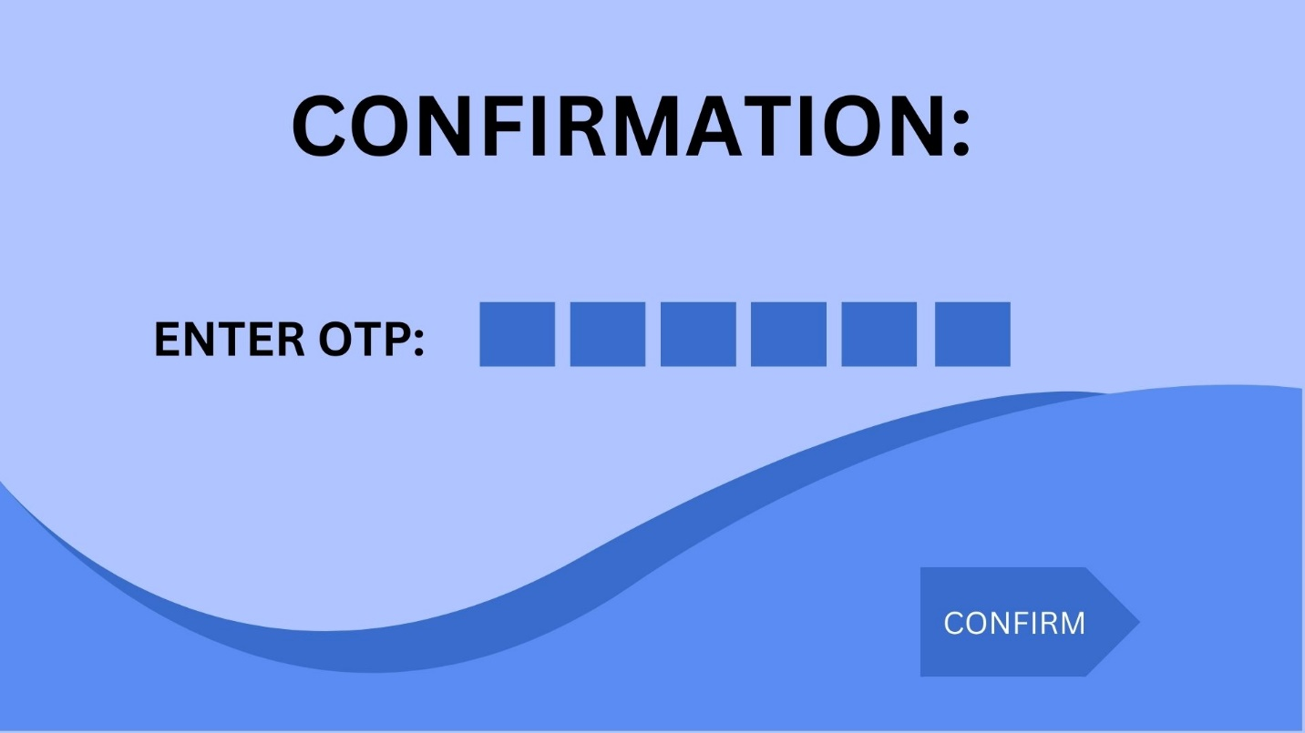

Number of External Inputs:1

Number of External Outputs:1

Number of External Inquiries:0

Number of External Interfaces:1

Number of Internal Logical Files:0



Number of External Inputs:0

Number of External Outputs:1

Number of External Inquiries:0

Number of External Interfaces:0

Number of Internal Logical Files:1



Number of External Inputs:4

Number of External Outputs:1

Number of External Inquiries:0

Number of External Interfaces:0

Number of Internal Logical Files:1



Number of External Inputs:3

Number of External Outputs:1

Number of External Inquiries:0

Number of External Interfaces:0

Number of Internal Logical Files:1



Number of External Inputs:0

Number of External Outputs:1

Number of External Inquiries:0

Number of External Interfaces:0

Number of Internal Logical Files:0



Number of External Inputs:7

Number of External Outputs:1

Number of External Inquiries:0

Number of External Interfaces:0

Number of Internal Logical Files:1



Number of External Inputs:4

Number of External Outputs:1

Number of External Inquiries:0

Number of External Interfaces:0

Number of Internal Logical Files:1



Number of External Inputs:0

Number of External Outputs:0

Number of External Inquiries:0

Number of External Interfaces:0

Number of Internal Logical Files:0



Number of External Inputs:0

Number of External Outputs:0

Number of External Inquiries:0

Number of External Interfaces:0

Number of Internal Logical Files:0



Number of External Inputs:3

Number of External Outputs:1

Number of External Inquiries:0

Number of External Interfaces:0

Number of Internal Logical Files:1



Number of External Inputs:4

Number of External Outputs:0

Number of External Inquiries:0

Number of External Interfaces:0

Number of Internal Logical Files:1



Number of External Inputs:0

Number of External Outputs:0

Number of External Inquiries:0

Number of External Interfaces:0

Number of Internal Logical Files:0